**Brooklyn torah gazette**

**For parshas shemini 5782**

Volume 6, Issue 27 (Whole Number 282) 23 Adar II 5782/ March 26, 2022

**The Life of Rabbi**

**Chaim Kanievsky**

**By** [**Rabbi Shraga Simmons**](https://aish.com/authors/48865357?aut_id=3763)

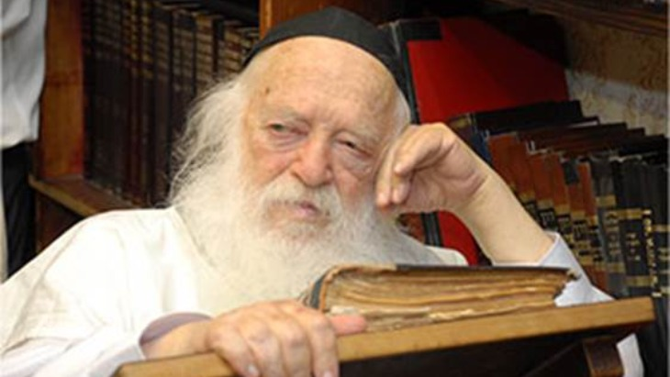

***Why did close to a million people go to this rabbi's funeral?***

Imagine discovering at the earliest age a passion for an endeavor for which you have an abundance of natural talent and skill. Add to that the head-start of growing up surrounded by the giants in your chosen field, who closely mentor your progress. For decades, thousands flocking to your home seeking sagely advice, and you produce dozens of scholarly volumes on the entire breadth and depth of your chosen field.

Add to that a single-minded focus and unwavering devotion to the goal – day after day, year after year - for 94 years.

That was the life of Rabbi Chaim Kanievsky - the undisputed Prince of Torah (Sar HaTorah) - who was buried today in the central Israel city of Bnei Brak, as hundreds of thousands converged to pay last respects.

**Early Years**

Shmaryahu Yosef Chaim Kanievsky was born in 1928 in Pinsk, now Belarus. His father, Rabbi Yaakov Y. Kanievsky, was the widely revered Steipler Ga’on. When Chaim was 6, the Kanievsky family moved to Israel. On the sea voyage, Chaim sat day after day with his father, absorbed in Torah study. As they neared the shores of the Holy Land, they were about to complete study of Exodus, when suddenly his father kissed the book and closed it. "Let's wait until we arrive," he explained, “so we can celebrate in the Holy Land."

This gave young Chaim not only an appreciation for the preciousness of Torah study, but also love for the land of Israel. Since then, he never departed the borders of Israel, and became a lifetime advocate for aliyah, encouraging people to move to Israel.

Rav Chaim never departed the borders of Israel, and became a lifetime advocate for aliyah, encouraging people to move to Israel.

Rav Chaim’s childhood home was the center of the Torah world, with people from around the world gathering there to confer with some of the greatest rabbis of the 20th century. Besides his revered father, Rav Chaim’s uncle was Rabbi Avraham Y. Karelitz (the Chazon Ish), the premier Torah leader during the critical years of Israeli independence. The Chazon Ish, himself childless, showered Rav Chaim with constant tutelage and individual attention, grooming him in the art of Torah scholarship.

Rav Chaim, a child prodigy with a photographic memory, elucidated complex talmudic teachings at a young age. As a boy, he studied at Yeshiva Tiferes Tzion in Bnei Brak, amusing himself during recess breaks – not with a ball or board game – but by counting the number of times various sages are quoted in the Talmud. For his bar mitzvah, he completed the Babylonian Talmud (Shas), a feat that many do not manage to achieve in a lifetime.

In the 1948 Israeli War of Independence, when five Arab armies attacked, a state of emergency was declared and every Israeli was mobilized into the IDF, no exceptions. At the time, Rav Chaim was a 20-year-old student at the Lomza Yeshiva in Petach Tikva.

On one occasion, a truck pulled up to the yeshiva and transferred all the students to the site of artillery fighting near Tel Aviv. Rav Chaim was ordered to climb a large hill and, due to the vast shortage of armaments, was given a stick and two stones to fend off potential attackers. Rav Chaim took along a volume of Talmud, climbed the hill and – in classic form – managed to study Torah the entire time until the skirmish was over.

Rav Chaim married Batsheva, the daughter of Judaism’s leading legal decisor, [Rabbi Yosef S. Elyashiv](https://aish.com/a_portrait_of_greatness/) (and granddaughter of Rabbi Aryeh Levine, beloved Tzaddik of Jerusalem). Rav Chaim’s illustrious lineage was unmatched, although that alone is insufficient to ensure success. Metaphorically, “nine zeros is not a billion” unless an actual number is added in front. So too, Rav Chaim was surrounded by Judaism’s leading Sages, but what he added at the beginning made it all count.

**Torah Study**

Rav Chaim was a private citizen, leading no synagogue or yeshiva, and with no official teaching or rabbinic position. For years, he occupied a nondescript seat in Kollel Chazon Ish, conducting uninterrupted in-depth research and writing. Once, as a young man, he considered taking a paid position, but his father said: “Your contribution is to sit and learn. Period.” With commitment and diligence, Rav Chaim never wavered from that advice, becoming this generation’s paradigm of nonstop Torah study.

Inside Rav Chaim’s modest home on Rashbam Street, every room and hallway were lined with bookshelves, crammed with thousands of Torah books. On Shabbat, Rav Chaim would play a game with his children. One of them would name a book title, and Rav Chaim would educate and entertain the children by immediately telling them its precise location among the volumes filling every inch of wall space.

Rav Chaim maintained a breathtaking schedule, waking at 2 a.m. for a rigorous 20-hour-a-day study of the entire biblical and rabbinic corpus including Tanach, Mishnah, Babylonian and Jerusalem Talmuds, Midrashim, Zohar, and all the primary works of Jewish law: Maimonides’ *Mishneh Torah*, *Tur*, *Shulchan Aruch* (Code of Jewish Law), and *Mishnah Berurah*.

Rav Chaim toiled day and night, saying that the mental energy expended on Torah study is more physically taxing than digging ditches or laying bricks. Few people manage to study so many intricate works in a lifetime. Rav Chaim completed them all - every single year.

When a wealthy visitor once offered to buy them a spacious house, they declined, explaining that it encourages people to see that economic hardship does not preclude devotion to Torah study.

The Kanievsky’s had a small apartment, and the young children slept in a room filled to the brim with beds. When a wealthy visitor once offered to buy them a spacious house, they declined, explaining that it encourages people to see that economic hardship does not preclude devotion to Torah study.

Rav Chaim learned before dawn with a study partner and they wanted to be able to awaken and study right away. Despite the already over-crowded conditions, a spot was found for the study partner to sleep in the Kanievsky’s apartment on a regular basis.

Rav Chaim published dozens of volumes that are modern classics, including Derech Emunah, Derech Chochma, Shoneh Halachos, and Ta'ama D'kra. With unparalleled breadth of knowledge, Rav Chaim was uniquely qualified in obscure topics of Jewish law, such as lunar cycles, agricultural laws in Israel, and a groundbreaking commentary on the Jerusalem Talmud.

*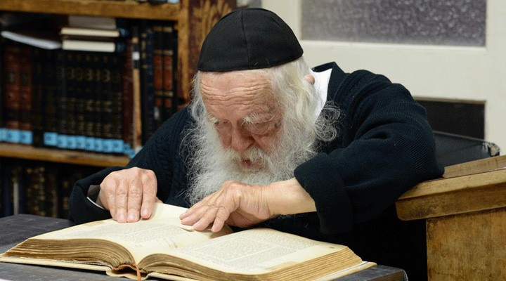****Rav Chaim studies in his Bnei Brak home***

Additionally, Rav Chaim authored tens of thousands of rabbinic responsa on nearly every conceivable aspect of Torah. Each week he would sequester himself in a room with stacks of hundreds of letters, and patiently responded to every single one. Due to the sheer volume and to maximize his time, Rav Chaim’s responses were record-breaking brief – typically a single line, and often limited to one word in microscopic letters, occasionally adding a reference to the Jewish codes.

Rav Chaim made an art out of brevity. When delivering words of encouragement, to save precious seconds, he invented the word “Boo-ha,” an acronym for “blessings and success.”

As the world’s most learned sage, Rav Chaim had insights into every possible dilemma – personal, communal, or global. Despite his reluctance to take a position of public leadership, tens of thousands of people from around the world - politicians, businesspeople, educators, and foreign dignitaries - flocked to Rav Chaim’s modest home on Rashbam Street.

At appointed times each day, the steep staircase outside Rav Chaim’s home would be lined with visitors waiting to enter, with lines often snaking around his house. Thousands would enter his inner chamber for blessings, inspiration, and sage advice from this humble human being, endowed with Divine guidance. Preferential treatment was given to little boys celebrating their third birthday, the day of their [upsherin](https://aish.com/48964501/) (first haircut), as Rav Chaim recognized the challenge of asking young children to wait in line.

For most of Rav Chaim’s life, he left decisions on communal matters to others. A few years ago, when I went to consult with Rav Chaim regarding a project of communal concern, he listened to my question and then – characteristically – sent me to consult with his Bnei Brak colleague, [Rabbi A.Y.L. Shteinman](https://www.thejewishstar.com/stories/rabbi-shteinman-ztl-humble-giant-of-torah,14843). Rav Chaim often expressed tremendous gratitude to Rabbi Steinman for shouldering that burden of responsibility, enabling Rav Chaim to continue his studies uninterrupted.

**In My Home**

Rav Chaim was renowned for being honored multiple times - every day - as sandek, holding the baby at a Bris Milah. In 1999, Rav Chaim accepted an invitation to the Bris of my son. At the appointed hour, he swept through the front door of my home and, with nary a word, unfurled the tattered tallis – inherited from his saintly father – that he wore at every bris. In our living room, Rav Chaim served as sandek, lovingly dropping wine into the baby’s mouth, imparting spiritual influence on the baby, and praying intently for his future success.

Serving as sandek is considered a merit for becoming wealthy, and someone once asked Rav Chaim, "If you serve so often as sandek, why are you not wealthy? He replied that “wealth” is not limited to money, and quoted his father that wealth is attained by publishing Torah commentaries. Rav Chaim added his own opinion that grandchildren are a source of tremendous wealth.

Rav Chaim’s time was highly structured, and keeping to such a rigorous schedule comes with intendant risks, particularly regarding one’s private life. Rebbetzin Kanievsky had every right to voice opposition to this hyper-focus on Torah study, which ostensibly came at her expense. Yet she was his biggest supporter. Someone once made Rav Chaim a generous offer, which involved him spending two minutes not related to Torah study or community matters. Rav Chaim presented the proposal to his wife, who nixed the idea, saying that two additional minutes of Torah study were worth more to her than anything else.

Fittingly, Rav Chaim passed away on Shushan Purim, a day when Haman – descendant of the biblical Amalek – fought to annihilate the Jewish people. Amalek represents ideologies antithetical to Torah; the best weapon we have against that is the study and practice of Torah. For 94 years, Rav Chaim Kanievsky fulfilled that mandate to the utmost.

With thanks to “[A Gadol in Our Time](https://www.artscroll.com/Products/YRCKH.html): Stories about Rav Chaim Kanievsky” by Libby Lazewnik (ArtScroll Publications).

*Reprinted from the March 20, 2020 website of Aish.com*

**Rav Avigdor Miller on**

**The Curse of Leisure Time**



**QUESTION:** **Isn’t the added leisure time in modern society a sign that generations are improving because it means Hashem trusts us to do better things with our free time?**

**ANSWER:** Isn’t the fact that we have more leisure time today a sign min hashomayim that we’re better because it means that we’re more capable of using our leisure time?

And the answer is – now you might condemn me for these words but I’m not going to back out no matter what you think.  I’ll tell you anyhow. I say it was a big mistake when they started instituting limited hours for laborers.  It was an error because all they did was to slow down to production.

America was once the leader in the world’s industry.  Today, America is being shouldered out by other countries.

You know that Japan is flooding America with products.  Just look at the tape recorders wherever you are.  They’re all Japanese; which means millions of Americans are deprived of opportunities because of that.  And because of everything else that’s also being manufactured abroad.

The same thing happened in Great Britain; in England they made that tragic mistake.  They tied themselves up because it was a trade union government that gave so many privileges for the workers that they slowed down their production and today England is one of the worst producers. And they’re being shouldered out.

And therefore, the fact that it happened doesn’t mean it’s a good thing.  The fact is that when a man comes home early from work and he has a lot of legal holidays, there’s more time for him to injure himself.  He’ll look for unlawful pleasures.

I remember the good old days when people came back Saturday late from work.  The gentile workman came back late Saturday from work.  He had his pay with him and he came back late.  He went into his home, he ate supper, got drunk, fell asleep and he woke up in the morning and he went to church.  And Monday morning he was back on the job.

**Very Few Legal Holidays**

Legal holidays were very few.  Very few legal holidays.  In those days, they didn’t have Veteran’s Day yet. They didn’t have a lot of these days that were instituted later.  And it was better for them.  They lived much longer.  They had less heart failures.  You have to know when a man works, work is a prophylactic.  Work is vitamins.  Work is a lifesaver.  You don’t realize.  גדולה מלאכה.  Melacha, work is a lifesaver for people.

But of course, what I’m saying is not the modern idea and therefore people will condemn me for that; but I say it anyhow.  I say it’s a big mistake.  And I repeat what I always say, that every time there’s a legal holiday a thousand more gentiles get killed on the highways who would have lived had it not been a legal holiday. Because there’s more opportunity, more leisure time, to commit mayhem on each other; more speeding on the highways and more collisions.  There’s more opportunity to go to low places, to dives, and to experience narcotics.

**Leisure is a Curse**

And therefore, it’s the same story.  Leisure is not good; it’s a curse.

Why is Hashem giving it to us?  Because it’s a punishment. It’s a punishment!  Pay attention to that.  And we’re suffering the results of leisure.  We’re suffering very much.  It would be a great blessing if we became once more an industrious and frugal nation like we were in the olden days.  Then we’d be healthier and more moral.  People turn to wickedness, to immorality only because of leisure time.  הבטלה מביאה לידי זימה – leisure brings to immorality.

Of course, the frum Jews benefit.  The more leisure they have – from the frum Jew, that’s how it’s supposed to be – the more they can go to shul, the more they can learn.  So, there is a benefit there.  And it could be that’s one of the factors, it happened for the sake of the frummeh; but it’s not enough because even the frummeh are enjoying the leisure in ways that are not entirely intended by Hakodosh Boruch Hu.

And therefore, don’t think it’s a blessing.

*Reprinted from the March 6, 2022 email of Toras Avigdor. Adapted from Tape #269*

**The Spiritual Significance**

**Of the Number “Eight”**

**From the Talks of the Lubavitcher Rebbe**

**Rabbi Menachem Mendel Schneerson, Zt”l**

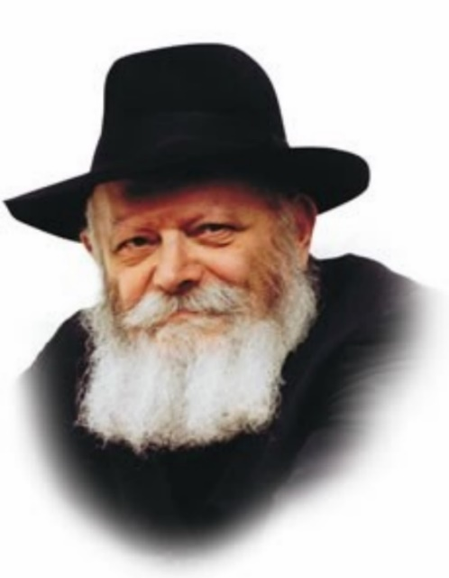

Last week, in the portion of Tzav, Moshe commanded Aharon and his sons to ready the Sanctuary's altar for G-d's holy Presence.

These preparations took seven days to complete, and are referred to as the seven days of consecration, as it states, "From the door of the Tabernacle of Meeting you shall not go forth seven days... seven days shall your consecration last."

At long last the much-anticipated day arrived. In the very first verse of this week's reading, Shemini, Moshe informs the Jews that the Divine Presence is about to descend: "And it came to pass on the eighth day that Moshe called...and said...for this day G-d will appear to you."

Indeed, it was a great day for the Jewish people, for it marked the commencement of an entirely new era in which G-d's Presence would rest in the Sanctuary.

Nonetheless, although this was the first day of the new era, we see that it is called "the eighth." Why? The term "eighth" expresses the day's unique advantage. In fact, the number eight alludes to a distinct and important attribute.

As a general rule, in Jewish thought the number seven belongs to the realm of nature, whereas the number eight corresponds to the realm of holiness.

The physical world (and the entire natural order) is based on a cycle of seven: seven days of the week, seven years of the Sabbatical cycle of working the land, etc.

The number eight, by contrast, connotes a holiness that is super-natural, a level that transcends the natural order. Some examples: brit mila (circumcision) is performed on the eighth day after birth; the highest level of holiness occurs on the eighth day of Sukkot, on Shemini Atzeret; and the harp that will be played in the Third Holy Temple will consist of eight chords. Similarly, the Divine Presence descended upon the Sanctuary on the eighth day of consecration.

Yet the words "on the eighth day" indicate a relationship to the days that preceded it, for the level of "eight" can only be attained after the preparation of "seven."

One mustn't think that G-d will bestow these higher levels of holiness without effort. A Jew has to prepare himself properly before meriting this more exalted level of Divine revelation. Indeed, it was only after seven days of intense preparation that the Jewish people became worthy of the supernatural holiness that descended on the eighth day.

At present we are anticipating the building of the Third Holy Temple in Jerusalem. In the Messianic era we will experience the highest level of holiness, alluded to in the eight strings of Moshiach's harp. At the same time, we must realize that the attainment of this level is dependent on our actions now, during these last few minutes of exile.

*Reprinted from the Parshat Shemini 5757/1997 edition of L’Chaim. Adapted from Likutei Sichot Vol 3.*

**Speaking with Care**

**The Wisdom of Silence**

Shlomo HaMelech said, “There is a time to speak and a time to be silent.” Chazal teach us to speak words of Torah, but to minimize unnecessary chatter. )

Rabban Shimon ben Gamliel said, “All my days I have grown up among chachomim and have found nothing more beneficial for a person than silence.” Rebbi Akiva said, “A fence around wisdom is silence.” This refers to unnecessary speech in worldly matters. Chazal say that silence is good for the wise; how much more is this true for others. The best remedy is silence, for it spares a person from many issues.

**Rambam speaks of five kinds of speech:**

(1) speaking as a mitzvah – such as studying Torah, which is equal to all other mitzvos;

(2) forbidden speech – like falsehood, lashon hara, cursing others and unclean language;

(3) Redundant speech which brings neither benefit nor harm – such as discussing current events and the news.

(4) Commendable talk – praising positive things and noting the damaging effect of negative things. This includes praising the righteous and their doings so that others will follow their ways, and degrading the sinners and their conduct so that they will be despised in the eyes of all. This can also be done by relating a story or singing a song.

(5) Permissible speech – that which is necessary for day-to-day living and for business.

One should try to concentrate most of his speech on that which is a mitzva and commendable, and minimize the rest. )

In Eretz Yisroel they would say, “Speech is worth a sela, silence is worth two,” implying that even permissible speech should be limited.

Chazal observe that HaShem placed the tongue behind two walls, the teeth and the lips, so that one refrain from inappropriate speech.

**Two Ears and One Mouth**

It is said that a person was created with two ears and one mouth, so that he knows to minimize his speech. The Me’iri writes: Unnecessary speech is no different than the sounds made by animals.

**Holy Speech**

Since the power of speech is an expression of the Shechina within a person, one must try to use it for holy purposes. For this reason, the tongue is hidden in the mouth, just as a treasure is kept concealed and locked.

After the passing of R. Yehuda ben Shoshan in the upper Galil, he appeared in a dream to his talmid R. Lapidos; his face shone like the sun and each hair in his beard, like a blazing torch. The talmid asked what he had done to merit such kedusha, and he replied that throughout his lifetime he had not spoken unnecessarily. A person’s speech is similar to malochim and one should use it for kedusha.

The great chossid and mashpia Rashbatz would advise the chassidim who would fast, “Instead of fasting with your stomach, fast with your mouth!”

R. Levi Yitzchak of Berditchev would explain the possuk, “One should not desecrate his word; whatever leaves his mouth he should fulfill,” to mean that if one guards his speech, everything he says will be fulfilled by HaShem.

**Think Before You Speak**

The chossid R. Zev Vilenker said about himself, “The Alter Rebbe’s look affected me in such a way that I should never speak without thinking.” Indeed, throughout his entire life, whenever a motion or hint would suffice, he would abstain from speaking.

R. Nachman of Breslov once said, “In our childhood we learn to speak, and as we age we learn to keep silent. That’s the problem! We learn to speak before we learn how to keep silent…”

R. Avrohom, the Trisker Maggid,, once said, “For yourself you do not need to speak, for thought would suffice; you only speak for the benefit of your friend. Stop and think for a moment: perhaps your friend is not interested in this ‘favor’ of yours…”

When R. Simcha Bunim of Pshischa was instructed by his Rebbe, the Chozeh of Lublin, to journey to a small town, he asked some chassidim to join him, and they set out without knowing the purpose of their trip. When it was time to eat, R. Simcha and the chassidim were informed by their host that they were going to be served fleishigs, whereupon they began to question how the food had been prepared and delved into many halachic details.

Suddenly, they were interrupted by a beggar, warming himself near the fireplace, “You are so careful with what goes into your mouths, but you don’t monitor what comes out – your words!” When R. Simcha Bunim heard this, he understood why his Rebbe had sent him, and promptly set out on his journey home.

*Reprinted from the Parshat Tzav 5782 edition of the Weekly Farbrengen.*

**These are the animals you may eat ... whichever divides the hoof and chews the cud (11:3)**

Chazal say that when Moshe went to receive the Torah, the angels objected, "Put Your grandeur in the heavens [Tehilim 8:2]. Give the Torah to us."

To this Hashem replied, "Are you the same angels who went to visit Avraham and ate meat and milk?!"

We see, notes R' Yoel Teitelbaum, zatzal (1887-1989; the "Satmar Rav"), that one can lose the whole Torah because of a single non-kosher meal. (Haggadah of the Chassidic Masters by Rabbi Shalom Meir Wallach, ArtScroll)

*Reprinted from the Parshat 5782 email of whY I Matter, the parsha sheet of the Young Israel of Midwood in Brooklyn, edited and compiled by R’ Yedidye Hirtenfeld.*

**Rabbi Berel Wein**

**On Parshas Shmini**

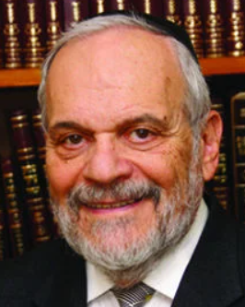

All living creatures that exist in our world require nutrition to be able to survive. Human beings, being the most sophisticated of all creatures on this planet, are especially concerned with the food that they eat. Most human beings know that they eat to survive, but there are many, especially in Western society today, that survive to be able to eat.

The variety of foods, recipes and menus that are designed by human beings for their food consumption is almost endless. And medical science has shown us that what and how we eat affects our health, longevity, psychological mood and even our social standing. As such, it becomes almost logical and understandable that the Torah, which is the book of life and of human beings, would suggest and ordain for us a list of foods that somehow would prove harmful to our spiritual health and traditional growth, to prevent man from harm.

In this week's Torah reading, we are presented with such a list of forbidden and permissible foods available for the consumption by the Jewish people, for them to maintain their status as a kingdom of priests and a holy nation. The Torah, in effect, is telling us that the physical foods that we consume somehow affect our inner souls, psyches and patterns of behavior. We are what we eat!

One of the hallmarks of Jewish survival throughout the ages has been the observance of the laws pertaining to kosher food, which takes on not only a physical dimension but an overriding spiritual dimension as well. What Jews eat has become the standard to measure the level of piety and tradition that exists within the national entity of the people of Israel.

The Talmud is of the opinion that eating non-kosher food somehow affects our spiritual senses. Commentators thought that eventually generations of Jews who unfortunately consumed non-kosher food became less charitable with their wealth, talents, and time. I know of no survey or statistical study that relates to this issue. However, in my many years as a rabbi of a congregation and as a fundraiser as well, I have noticed that generations of Jews who have assimilated and are no longer observant tend to be less committed towards charitable Jewish causes that were helped by their kosher food-eating ancestors.

There is no question that the laws of kosher food have contributed immensely to the survival of the Jewish people and the strengthening of Jewish core values throughout the ages. Kosher food was and is the hallmark of the Jewish people and remains a bulwark against the ravages of intermarriage and the adoption of value systems that are antithetical to Torah values and traditional Jewish societal life.

Perhaps even more than having a mezuzah on the doorpost, having a kosher kitchen brought a feeling of spirituality and godliness into the home, no matter how modest its physical appearance and stature may have been. It is ironic in the extreme that in our current world, where kosher food is so readily and easily available, and with so many varieties of Kosher food, which can satisfy any gourmet pallet, tragically so many Jews have opted out from the observance of eating kosher in their daily lives. A renewed drive to promote the kosher home in all its aspects is certainly needed.

*Reprinted from this week’s website of rabbiwein.com*

**Parshas Shemini**

**Food for the Soul**

**By Rabbi Ben Tzion Shafier**



*“ Tell Bnei Yisroel, “These are the creatures you should eat.” Vayikrah 11:2*”

When the Torah introduces the animals that we may and may not eat, it uses the expression “*chaya.*” Rashi explains this as a play on the word “*chay*,” meaning, “you should live.” He explains this according to the *Medrash* *Tanchuma*:

*The Torah forbids us from eating non-kosher foods because we are fit to live for eternity. The nations of the world were created for their place in this world only. Therefore, it isn’t necessary for them to avoid non- kosher foods. But the Jews were created with a soul that will last forever, and so we are warned to avoid such foods.*

*This can be compared to a doctor who went to visit two critically ill patients. To the first one he gave strict instructions, “This you may eat; this you may not eat.” however to the second patient he said, “You may eat whatever you like.” When questioned on the difference in directives, the doctor responded, “The first patient, while gravely ill, will recover. So, it is imperative that he eat wholesome foods that will aid in his healing. The second patient will not survive. There is no point in his watching his diet Let him eat what he enjoys.”*

With this *moshol,* the *Medrash* explains why the Torah forbids us from eating *treif* food. Since we were created to last for eternity, we must avoid those foods that will damage us. The nations of the world, in contrast, were only created for this world, so they can eat what they want.

This is difficult to understand. What comparison does eating non-kosher food have to a sick man eating a specific diet? The diet of healthy or non-healthy foods directly affects the health of a person. When a person eats wholesome foods, his body utilizes the nutrients and he gains strength. If he eats unwholesome foods, his body becomes weaker and he loses vitality.

This is the way of the world. However, this has nothing to do with the dietary laws that the Torah sets down. The reason we don’t eat *treif* food is a *chok,* a law without a reason, much like not wearing *shatnez* or not eating *chometz* on Pesach. How can the Medrash use this *moshol* of the diet of the two patients when it isn’t comparable to the *nimshol*?

**A fundamental Understanding of Man**

The *Chovos* *Ha’levovos* (*Sha’ar Avodas Elokim* 3) explains that HASHEM created man out of two very distinct parts – a *nefesh ha’Schili* (intellectual soul) and a *nefesh ha’bahami* (animal soul). Each has its desires and inclinations, and each is competing with the other, vying for primacy over man.

The *sechel* in man is what drives him to do all that is good and proper. It is the part of him that pulls him closer to HASHEM. It is the force in him that hungers to help others. Everything that is noble, proper and good in man stems from this side.

The *Nefesh Ha’bahami* on the other hand is comprised of the base instincts necessary for survival. This is a part of man just as it is in the rest of the animal kingdom. It is made up of hungers, appetites, and desires.

The *sechel* and *behaima* are constantly in competition with each other, and each is in a state of flux. Much like a muscle, each becomes stronger with use and atrophies with disuse. The more a person uses his *sechel,* the stronger and more dominant it becomes. The more he allows his passions and desires to rule, the stronger a hold they have on him. Man is engaged in a constant battle.

In this conflict, the *behaima* has an unfair advantage. It is in its element, and everything that we do constantly utilizes it and therefore strengthens it. All of man’s daily activities – from working for a living to eating and sleeping – are constantly nourishing the *behaima* side. Very little that a person does strengthens his *sechel*. And so by all rights, the *behaima* side of man should become ever stronger until it vanquishes the *sechel*.

For that reason, the Torah gave us strict instructions about which actions to engage in and which to avoid, as those actions give an undue strengthening to the *behaima* side of man.

**How Treif Food Functions**

Chazal tell us that “*treif food deadens the heart.*” When a person eats non-kosher food, he ingests that impurity into himself, so his *behaima* side becomes stronger, and it becomes more difficult for him to relate to anything spiritual. It becomes harder for him to learn, harder for him to *daven*, harder for him to experience HASHEM.

When Chazal call not eating *treif* food a *chok*, that refers to *how* it functions. Why does milk cooked together with meat give an unfair edge to the *behaima* side? Why does ingesting blood make a person cruel? To understand how these things function, one must be a *scientist of the soul* – something that very few individuals in history were able to become. But that it works that way is a given. And for that reason, the Torah forbids us from eating various foods, wearing *shatnez*, engaging in various physical relations...

This seems to be the answer for this Rashi. The *moshol* is exact. Since the Jew was given a soul that will last forever, he must be very guarded in what he eats. Impure food will deaden that holy part of him; it will damage his soul. A gentile, on the other hand, was not created with that same purpose, so it doesn’t matter if he eats these types of foods or not.

This concept is very applicable to us in the sense that we often overlook our predisposition for greatness. HASHEM created us with elevated souls, different than any of the other people who occupy this planet. We were created to live forever in an exalted and lofty state. We were given all of the inclinations and aptitudes to reach true greatness. Additionally, HASHEM gave us the greatest guide to spiritual perfection – the Torah. If we learn to follow its ways and appreciate its systems, we journey forward on the greatest mission of man – the road to perfection.

*Reprinted from the website of TheShmuz.com*